**Notes and questions about the results**

The results graphs are organized in folders according to the data rates. Each graph displays the average/standard deviation of 3-6 simulations of 60 seconds, CBR with 1460B packets, 1 point to point link in different distances – 10-100km.

In case you won’t be able to open the figure files, the main results are here:

* 1. Mbps (It’s 1 link and not 2 as written in the title)

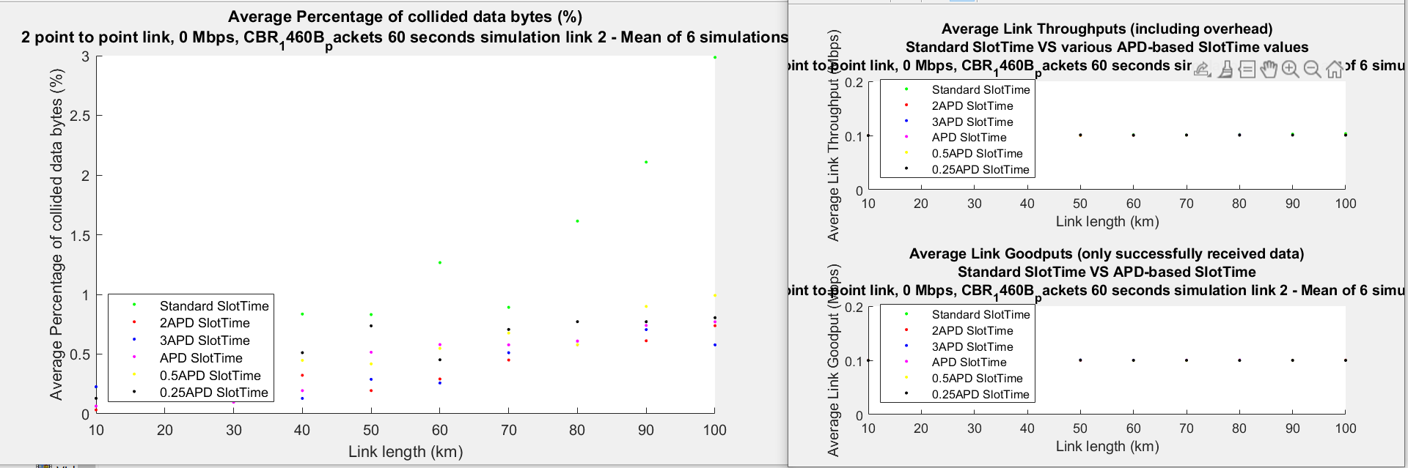

1. Mbps

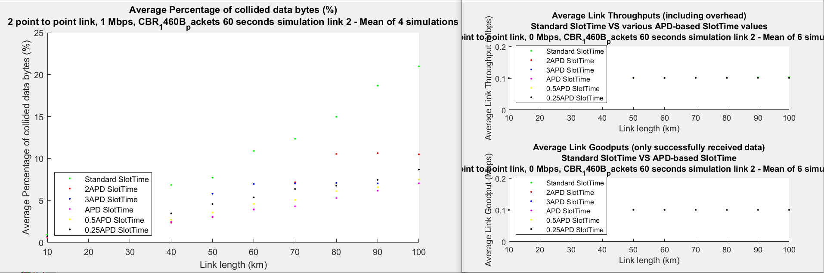

1. Mbps

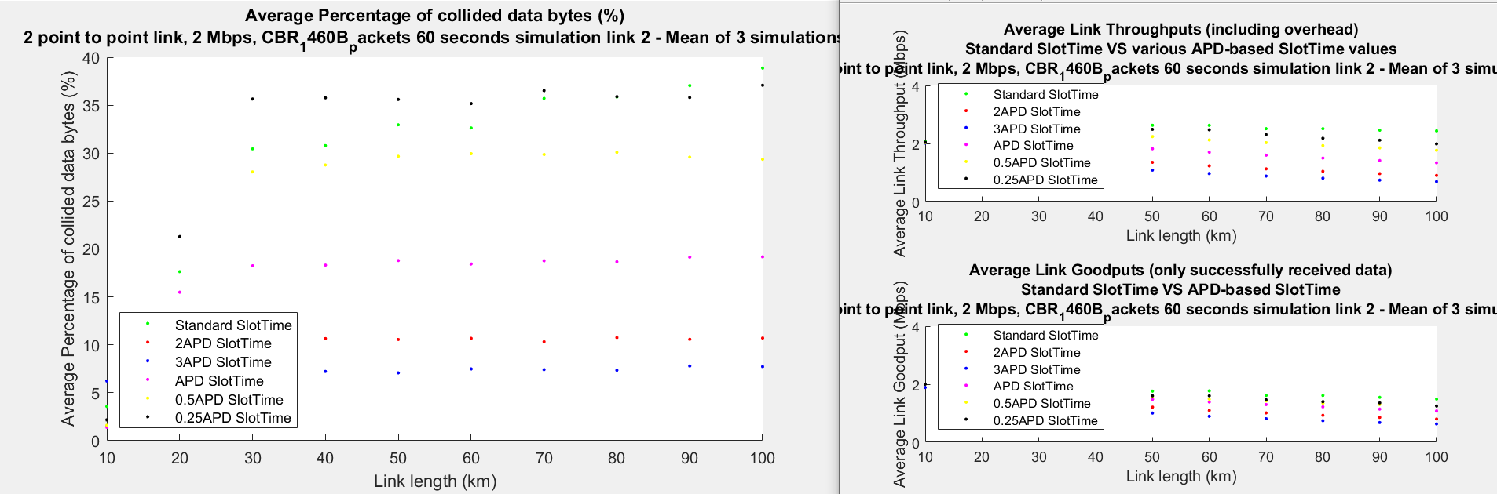

1. Mbps

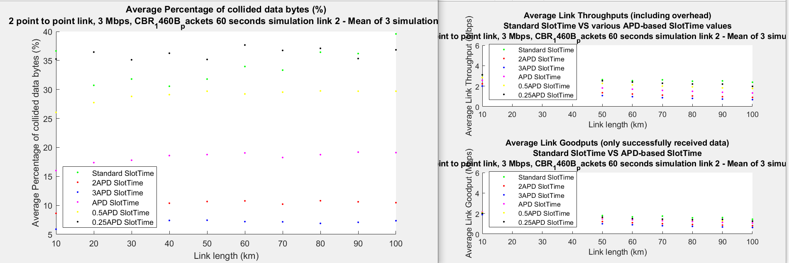

1. Mbps

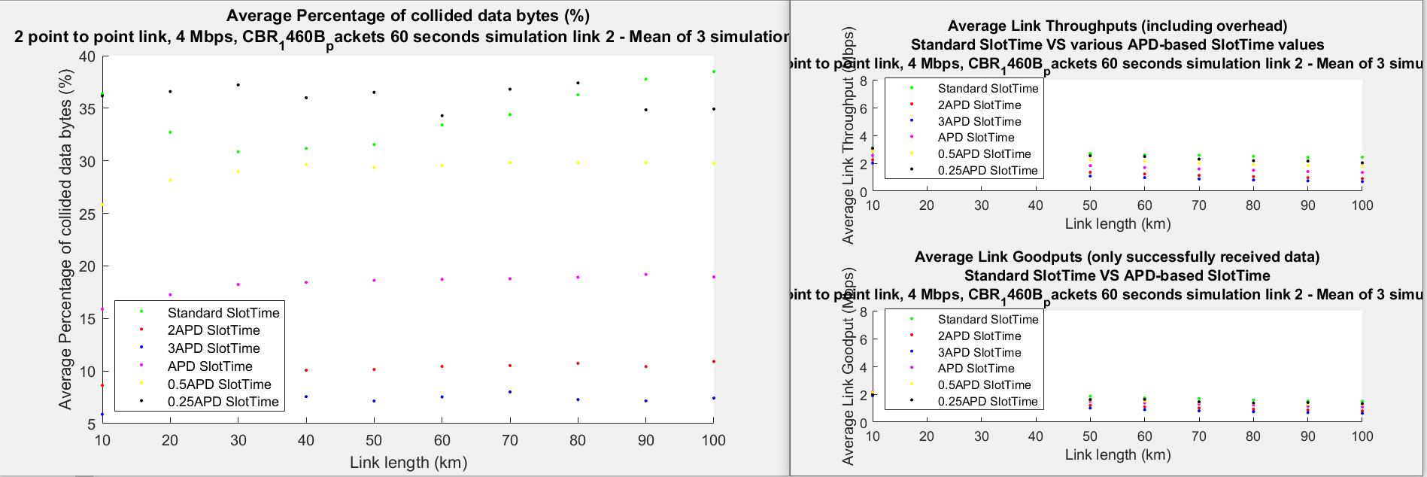

As we can see, there is a drop in the goodput in data rates higher than 2 Mbps (for all SlotTimes values including the standard).

The weird thing is that in 3Mbps and 4Mbps, the goodput is more or less the same as in 2Mbps (about 1.6Mbps for the standard SlotTime).

I assume that it could happen due to the relatively small PHY rate I used – 6Mbps. I have done some calculations, and the transmission time of one 1460B packet in this rate is 0.002 seconds. The inter arrival times in each data rate are as follows:

|  |  |
| --- | --- |
| Data Rate (Mbps) | Inter Arrival Time (s) |
| 0.1 | 0.1168 |
| 1 | 0.0117 |
| 2 | 0.0058 |
| 3 | 0.0035 |
| 4 | 0.0029 |

So it could be that in the higher rates, the IAT was too small comparing to the packet transmission time. Considering the big APD, I guess that a lot of packets haven’t had a chance to be sent, they stayed in the queue all long the simulation.

I think that increasing the PHY rate might change the results. What do you think?